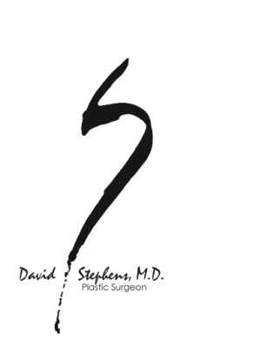

Coronavirus (COVID-19) Pre-Op Testing Patient Instructions

Why am I being tested for COVID-19?
Some people may have the virus even though they are not showing symptoms of being sick (asymptomatic). To decrease the risk of a respiratory or other complications and hospitalization to you as well as the risk of Covid spread to our staff, we require that all elective surgical patients to be tested for COVID-19 prior to having their procedure at our office.

When do I get tested for COVID-19?
Regardless of your vaccination status, you will be “Rapid” tested when you arrive to our office on the day of your surgery using the Abbott Nasal Rapid Test. We are no longer using the rPCR test 3 days prior to your procedure because although it is a very sensitive test, it has higher false positive results in those patients who had Covid previously. We want to know if you are actively carrying the Covid virus now and the “Rapid” test is best for this.

Pre-op testing for COVID-19 is required to be completed the day of surgery. What if my test is positive?
If your pre-op COVID-19 test is positive, Dr Stephens will determine how long your procedure should be delayed using published recommendations to allow for a chance to clear the virus.

What can I do to decrease my risk of contracting COVID-19 prior to surgery?
- Avoid large groups and gatherings for 7-10 days prior to your surgery. The 3 c’s are a good way to reduce risk of getting infected: AVOID CROWDED PLACES; CLOSED SPACES; CLOSE CONTACT! Wearing a good mask has been clearly shown to reduce becoming infected and to reduce spreading infection
- Practice social distancing by keeping at least 6-feet away from others.
- Wash your hands often with soap and water for at least 20 seconds, especially after going to the bathroom, before eating, after blowing your nose, coughing, or sneezing. AVOID TOUCHING YOUR FACE, EYES AND MOUTH If soap and water are not readily available, use an alcohol-based sanitizer
- with at least 60% alcohol. Always wash hands with soap and water if hands are visibly dirty.
- Avoid touching your nose, eyes and mouth.
- Clean and disinfect frequently touched objects with regular cleaning spray or wipes
- If you do develop symptoms of a cold, let us know and call your primary care doctor, and go to the emergency room if symptoms are severe. There are effective treatments for the flu and Covid 19

We look forward to seeing you when you arrive for your procedure.
If you have any questions, please call us at (425) 455-0444

